**THE GAMING ARCADE**

**Mini project of SDF Lab – II Lab**

Submitted By:

**KHYATI DUA 9921103021**

**SRIYUT SRIVAS 9921103016**

**RIYA ARORA 9921103018**

**NITIN KUMAR 9921103019**

Under the supervision of:

**Dr. Arti Jain**

**Ms. Devpriya Soni**



**May 2022**

**Abstract**

**Games can be a valuable tool for enriching computer science education, since they can facilitate a number of conditions that promote learning: student motivation, active learning, adaptivity, collaboration and simulation. Additionally they provide the instructor the ability to collect learning metrics with relative ease.**

**There has been interest in designing computer algorithms to play common games like tic tac toe, food snake, rock paper scissors and many more since the early advent of the modern digital age.**

**In this project report, classic games have been built on a computer based platform using C++ as a part of our SDF project. The primary goal for this project is to create a computer artificial intelligence based on several games. The report portrays how the program pursues the code and methodology for winning in the amusement.**

**Table of Contents:-**

**1:** **INTRODUCTION**

**2: Class Diagram**

**3: Project Code**

**4: Screenshots of Output Screen**

**5: Conclusion and Future Scope**

**INTRODUCTION:-**

In the following project we have focused on the basic understanding of C++ language, OOP and many external functions which is being used to create a virtual gaming arcade. We have put to use our knowledge and practice of the language to incorporate datatypes, operators, looping statements, function and libraries provided in the given language and done our share of research to create the following games as a part of our project.

**GAME DISCRIPTION:-**

**1**.TIC- TAC- TOE: Tic-tac-toe (or Noughts and crosses, Os and Xs) is a pencil and-paper game for two players, X and O, who take turns marking the spaces in a 3x3 grid. The player who succeeds in placing three respective marks in a horizontal, vertical, or diagonal row wins the game.

**2**.FRUIT N SNAKE: In this virtual gaming arcade, we’ve created the game of Snake using C language. In this game of Snake, the player uses the arrow keys (or W A S D for movement) to move a "snake" around the terminal. When the snake eats the fruit, the score increments. The game ends when the snake touches the boundary. The goal is that we can entertain the user by liberating them from stress for a while.

**3**.ROCK PAPER SCISSORS: The game of Rock-Paper-Scissors (RPS) involves two players simultaneously choosing either rock (r), paper (p), or scissors (s), Player v/s Computer.That is, if one player selects rock and the other selects paper then the latter player wins, and so on. If two players choose the same item then the round is a tie.

**4**. HAND CRICKET: A new way to play the same old game. Hand cricket is a game played by many school kids for fun. It uses the concepts of cricket and played with hands. Hand Cricket is a game in which two players show scores on their respective fingers. If the scores are equal, the batsman is declared out. Else, the score of the batsman is added to the total runs of the batting team. In this game also we have put the option to play with computer, that too with the name of our Indian cricket team players or by using your own name. Hand Cricket will let you relive your past and provide you an enhanced experience with all the different and innovative features.

**5**. DRUNK MAN GAME: This is an interactive console animation app, where your choice of character (any letter from a to z) will appear to move funnily from start to finish line. If he finishes the race within the specified counter (in our case, 1000000), then we print a particular message, else another message.

**6**. Casino Game: In Casino we have to guess a number and if the number is matched with the Winning Number or Random Number than you will win the Lots of Money. Here in the programming language, we have a random number instead of Guess the number is real life. Let explanation our code step by step, first we will Take a Username and total amount of Money in Deposit, now player can play a Casino Game or Number Guessing Game but before playing a game player need to Bid for every time.

**CLASS DIAGRAM**

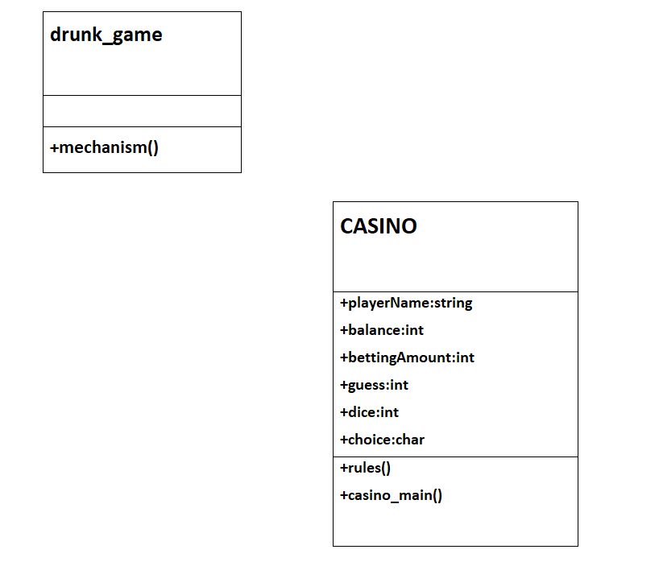

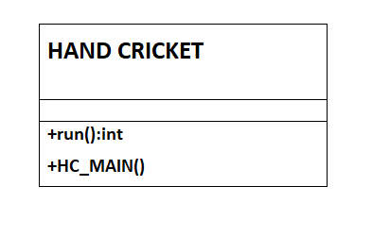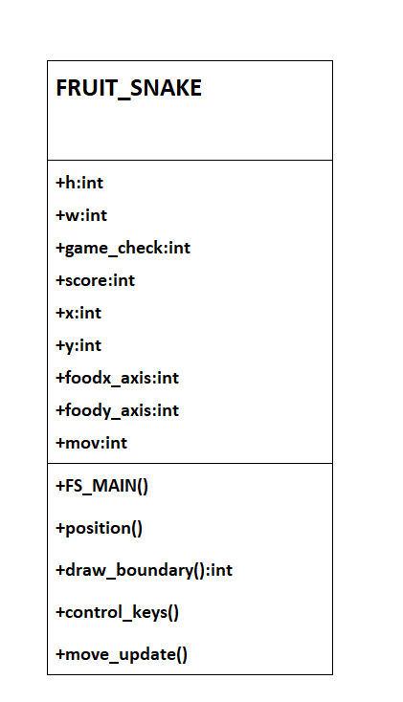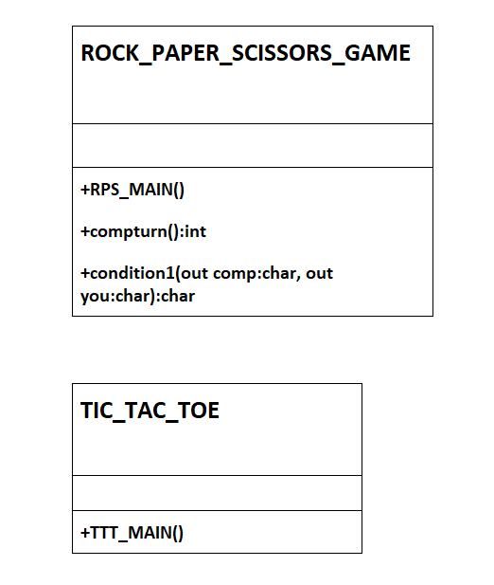

**PROJECT CODE**

#include <bits/stdc++.h>

#include <string> // Needed to use strings

#include <cstdlib> // Needed to use random numbers

#include <ctime>

#include<windows.h>

#include<conio.h>

using namespace std;

//****************************************************************FRUIT SNAKE*******************************************************************

class FRUIT_SNAKE{

private:

int h = 20, w = 50;

int game_check, score;

int x, y, foodx_axis, foody_axis;

int mov;

public:

void FS_MAIN()

{

system("color 2");

system("cls");

cout<<"============================================================\n";

cout<<" WELCOME TO FRUIT SNAKE GAME\n";

cout<<"============================================================\n";

//PlaySound(TEXT("C:\\Users\\user\\Downloads\\snakeopen.wav"),NULL,SND_SYNC);

Sleep(500);

for(int i=5;i>=1;i--)

{

cout<<" "<<i<<" SECONDS\n";

//PlaySound(TEXT("C:\\Users\\user\\Downloads\\snakebeep.wav"),NULL,SND_SYNC);

Sleep(500);

}

int your_score;

// Generate boundary

position();

// Until the game is over

while (!game_check)

{

system("color 2");

your_score=draw_boundary();

if(your_score>=150)

break;

control_keys();

move_update();

}

cout<<"\n+---------------------+\n";

cout<<"| FINAL SCORE IS "<<your_score<<" |\n";

cout<<"+---------------------+";

//PlaySound(TEXT("C:\\Users\\user\\Downloads\\snakelose.wav"),NULL,SND_SYNC);

Sleep(500);

}

void position()

{

game_check = 0;

x = h / 2;

y = w / 2;

g1:

foodx_axis = rand() % 20; //0 - 19

if (foodx_axis == 0 || foodx_axis == 19)

goto g1;

g2:

foody_axis = rand() % 50;

if (foody_axis == 0 || foody_axis == 49)

goto g2;

score = 0;

}

int draw_boundary()

{

system("cls");

for (int i = 0; i < h; i++)

{

for (int j = 0; j < w; j++)

{

if (i == 0 || j == 0 || j == w - 1 || i== h -1)

{

cout<<"#";

}

else

{

if (i == x && j == y)

cout<<"0"; //snake

else if (i == foodx_axis && j == foody_axis)

cout<<"*";

else

cout<<" ";

}

}

cout<<"\n";

}

// Print the score after the

// game ends

if(score<=50)

cout<<"NOT BAD, KEEP GOING!\n";

else if(score>50 && score<=100)

cout<<"WELL, THAT'S A GOOD SCORE\n";

else if(score < 150 && score>100)

{

cout<<"YOU'RE ABOUT TO WIN!\n";

}

else if(score >= 150)

cout<<"\nCONGRATULATIONS, YOU WON THE GAME !!\n";

return score;

}

void control_keys()

{

if (kbhit())

{

switch (getch())

{

case 75:

case 'A':

case 'a':

mov = 1;

break;

case 80:

case 's':

case 'S':

mov = 2;

break;

case 77:

case 'd':

case 'D':

mov = 3;

break;

case 72:

case 'w':

case 'W':

mov = 4;

break;

case 27:

//case 'ESC':

game_check = 1;

break;

}

}

}

void move_update()

{

Sleep(0);

switch (mov)

{

case 1:

y--;

break;

case 2:

x++;

break;

case 3:

y++;

break;

case 4:

x--;

break;

default:

break;

}

// If the game is over

if(x < 0 || x >= h|| y < 0 || y >= w)

game_check = 1;

// If snake reaches the fruit

// then update the score

if (x == foodx_axis && y == foody_axis)

{

g3:

foodx_axis = rand() % 20;

if (foodx_axis == 0 || foodx_axis == 19)

goto g3;

//PlaySound(TEXT("C:\\Users\\user\\Downloads\\snakefood.wav"),NULL,SND_SYNC);

fflush(stdin);

g4:

foody_axis = rand() % 50;

if (foody_axis == 0 || foody_axis == 49)

goto g4;

score += 5;

}

cout<<"CURRENT SCORE = "<<score;

cout<<"\n";

cout<<"PRESS ESC TO QUIT THE GAME: ";

}

};

//*******************************************************************R P S**************************************************************

class ROCK_PAPER_SCISSORS_GAME{

public:

void RPS_MAIN()

{

system("color E0");

int pp = 0, cp = 0, p1choice, p2choice ,choice , rounds,rps_choice,p1_score=0,p2_score=0; //cp-> comp points pp-> player points

char playerChar, compChar,p1,p2;

char elements[] = {'r', 'p', 's'}; // 1-1 2-1 3-1

cout<<"\t\t\t\t\t\t\t\t o--------------------o\n";

cout<<"\t\t\t\t\t\t\t\t |WELCOME TO ROCK PAPER SCISSORS|\n";

cout<<"\t\t\t\t\t\t\t\t o--------------------o";

system("cls");

cout<<"\t\t\t\t\t\t\t\t ENTER THE NUMBER OF ROUNDS: ";

cin>>rounds;

cout<<"\n\t\t\t\t\t\t\t\t PLAYER v/s COMPUTER ";

//PlaySound(TEXT("C:\\Users\\user\\Downloads\\rpsopen.wav"),NULL,SND_SYNC);

for (int i = 0; i < rounds; i++)

{

cout<<"\n\t\t\t\t\t\t\t\t Press 1 for ROCK\n\t\t\t\t\t\t\t\t Press 2 for PAPER\n\t\t\t\t\t\t\t\t Press 3 for SCISSORS\n\n";

cout<<"\t\t\t\t\t\t\t\t Player's turn: ";

cin>>choice;

playerChar = elements[choice - 1];

cout<<"\t\t\t\t\t\t\t\t -----------------\n";

cout<<"\t\t\t\t\t\t\t\t | You chose: "<<playerChar<<" |\n";

cout<<"\t\t\t\t\t\t\t\t -----------------\n\n";

cout<<"\t\t\t\t\t\t\t\t Computer's turn\n";

choice = compturn();

compChar = elements[choice - 1];

cout<<"\t\t\t\t\t\t\t\t --------------------\n";

cout<<"\t\t\t\t\t\t\t\t | Computer chose: "<<compChar<<" |\n";

cout<<"\t\t\t\t\t\t\t\t --------------------\n\n";

if (condition1(compChar, playerChar) == 'c')

{

cp++;

cout<<"\t\t\t\t\t\t\t\t You lost this round:\\n\n";

}

else if (condition1(compChar, playerChar) == 'd')

{

cout<<"\t\t\t\t\t\t\t\t It's a draw :\\\n\n";

}

else

{

pp++;

cout<<"\t\t\t\t\t\t\t\t You won this round :D\n\n";

}

cout<<"\t\t\t\t\t\t\t\t -------------\n";

cout<<"\t\t\t\t\t\t\t\t | You: "<<pp<<" |\n";

cout<<"\t\t\t\t\t\t\t\t | Computer: "<<cp<<" |\n";

cout<<"\t\t\t\t\t\t\t\t -------------\n\n";

cout<<"\t\t\t\t\t\t ===========================================================\n\n";

}

cout<<"\t\t\t\t\t\t\t\t -----------------\n";

cout<<"\t\t\t\t\t\t\t\t | Final Score |\n";

cout<<"\t\t\t\t\t\t\t\t -----------------\n";

cout<<"\t\t\t\t\t\t\t\t | You | Computer |\n";

cout<<"\t\t\t\t\t\t\t\t |------|----------|\n";

cout<<"\t\t\t\t\t\t\t\t | "<<pp<<" | "<<cp<<" |\n";

cout<<"\t\t\t\t\t\t\t\t -----------------\n\n";

if (pp > cp)

{

Sleep(3500*1);

system("cls");

cout<<"\n\t\t\t\t\t\t\t\t -------------------\n";

cout<<"\t\t\t\t\t\t\t\t | You Won the match |\n";

cout<<"\t\t\t\t\t\t\t\t -------------------\n";

//PlaySound(TEXT("C:\\Users\\user\\Downloads\\rpswin.wav"),NULL,SND_SYNC);

}

else if (pp < cp)

{

Sleep(3500*1);

system("cls");

cout<<"\n\t\t\t\t\t\t\t\t ------------------------\n";

cout<<"\t\t\t\t\t\t\t\t | Computer Won the match |\n";

cout<<"\t\t\t\t\t\t\t\t ------------------------\n";

//PlaySound(TEXT("C:\\Users\\user\\Downloads\\rpslose.wav"),NULL,SND_SYNC);

}

else

{

Sleep(3500*1);

system("cls");

cout<<"\n\t\t\t\t\t\t\t\t -------------\n";

cout<<"\t\t\t\t\t\t\t\t | It's a draw |\n";

cout<<"\t\t\t\t\t\t\t\t -------------\n";

//PlaySound(TEXT("C:\\Users\\user\\Downloads\\rpsdraw.wav"),NULL,SND_SYNC);

}

}

int compturn() //Generation of rand no. for comp's turn

{

srand(time(0));

int ct = (rand() % 3) + 1;

//PlaySound(TEXT("C:\\Users\\user\\Downloads\\rps.wav"),NULL,SND_SYNC);

return ct;

}

char condition1(char comp, char you) //CONDTIONS WILL CHECKED HERE

{

if (comp == you) //DRAW CONDITION

{

return 'd';

}

else if(comp == 'r' && you == 's')

{

return 'c';

}

else if (you == 'r' && comp == 's')

{

return 'y';

}

else if (comp == 'p' && you == 'r')

{

return 'c';

}

else if (you == 'p' && comp == 'r')

{

return 'y';

}

else if (comp == 's' && you == 'p')

{

return 'c';

}

else if (you == 's' && comp == 'p')

{

return 'y';

}

}

char condition2(char p1, char p2) //CONDTIONS WILL CHECKED HERE

{

if (p1 == p2) //DRAW CONDITION

{

return 'd';

}

else if (p1 == 'r' && p2 == 's') // p1 wins return p p2 wins return q

{

return 'p';

}

else if (p2 == 'r' && p1 == 's')

{

return 'q';

}

else if (p1 == 'p' && p2 == 'r')

{

return 'p';

}

else if (p2 == 'p' && p1 == 'r')

{

return 'q';

}

else if (p1 == 's' && p2 == 'p')

{

return 'p';

}

else if (p2 == 's' && p1 == 'p')

{

return 'q';

}

}

};

//***************************************************************CASINO GAME********************************************************************

class CASINO{

public:

string playerName;

int balance; // stores player's balance

int bettingAmount;

int guess;

int dice; // stores the random number

char choice;

void rules()

{

cout << "\t\t\t\t\t\t\t\t\t======CASINO NUMBER GUESSING RULES!======\n";

cout << "\t\t\t\t\t\t\t\t\t1. CHOOSE A NUMBER BETWEEN 1-10\n";

cout << "\t\t\t\t\t\t\t\t\t2. WINNER GETS 10 TIMES OF THE MONEY BET\n";

cout << "\t\t\t\t\t\t\t\t\t3. WRONG BET, AND YOU LOST THE AMOUNT YOU BET\n\n";

}

void casino_main()

{

srand(time(0));

cout << "\t\t\t\t\t\t\t\t\t==============================\n\t\t\t\t\t\t\t\t\t| WELCOME TO CASINO WORLD |\n\t\t\t\t\t\t\t\t\t==============================\n\n";

rules();

cout << "\n\nPLEASE ENTER YOUR NAME : ";

cin>>playerName;

cout << "\n\nENTER THE STARTING BALANCE TO PLAY GAME : $";

cin >> balance;

do

{

cout << "\n\nYOUR CURRENT BALANCE : $ " << balance << "\n\n";

do

{

cout << "HELLO, " << playerName<<endl;

cout<<"\n================================================="<<endl;

cout<<"ENTER AMOUNT TO BET : $ ";

cin >> bettingAmount;

cout<<"\n";

if(bettingAmount > balance){

cout << "BETTING BALANCE CAN'T BE MORE THAN CURRENT BALANCE!\n"<<endl;

cout<<"================================================="<<endl;

cout<<"\nRE-ENTER BALANCE\n ";

}

}

while(bettingAmount > balance);

do

{

cout << "GUESS ANY BETTING BETWEEN 1-10:";

cin >> guess;

if(guess <= 0 || guess > 10)

{

cout << "\n\nNUMBER SHOULD BE BETWEEN 1-10\n"<<endl;

cout<<"================================================="<<endl;

cout<<"RE-ENTER NUMBER:\n";

}

}

while(guess <= 0 || guess > 10);

dice = rand()%10 + 1;

if(dice == guess)

{

cout<<"================================================="<<endl;

cout << "\n\nWOOHOO! YOU'VE WON $ " << bettingAmount * 10;

cout<<"================================================="<<endl;

balance = balance + bettingAmount * 10;

}

else

{

cout<<"================================================="<<endl;

cout <<"OOPS! BETTER LUCK NEXT TIME"<<endl<<endl;

cout<<"YOU LOST $ "<< bettingAmount <<"\n";

cout<<"================================================="<<endl;

balance = balance - bettingAmount;

}

cout << "\nTHE WINNING NUMBER WAS: " << dice <<"\n";

cout<<"\n================================================="<<endl;

cout << "\n"<<playerName<<", YOU'VE BALANCE OF :$ " << balance << "\n";

cout<<"\n================================================="<<endl;

if(balance == 0)

{

cout<<"================================================="<<endl;

cout << "YOU'VE NO MONEY TO PLAY";

cout<<"================================================="<<endl;

break;

}

cout << "\n\n-->DO YOU WANNA PLAY AGAIN (Y/N)? ";

cin >> choice;

}

while(choice =='Y'|| choice=='y');

cout << "\n\n\n";

cout<<"================================================="<<endl;

cout << "\n\nTHANKS FOR PLAYING THE GAME. YOUR CURRENT BALANCE IS : $ " << balance << "\n\n";

}

};

//**************************************************************DRUNK MAN GAME***********************************************************

class drunk_game{

public:

void mechanism()

{

srand(time(0));

const int size=60;

string x;

int position = size /2;

cout << "Enter a name to begin \n ";

cin>> x;

while (true)

{

cout << "|START|" ;

for (int i=0; i<size;i++)

{

if (i == position)

cout << x;

else

cout << " ";

}

cout << "|FINISH|" << endl;

int move= rand()%3 - 1;

position = position + move;

if (position <1) {

cout << "You could not finish the race!" <<endl;

break;

}

if (position >size-1) {

cout << "Yay! You finished the race" << endl;

break;

}

for(int sleep=0; sleep< 1000000 ; ++ sleep);

}

}

};

//****************************************************************TIC TAC TOE**************************************************************

class TIC_TAC_TOE{

public:

void TTT_MAIN()

{

system("cls");

int choice;

cout<<"\t\t\t\t\t\t\t\t\t =====================\n\t\t\t\t\t\t\t\t\t \\ TIC TAC TOE /\n\t\t\t\t\t\t\t\t\t / \\\t\t\t\t\t\t\t\t\t\t\t\t\t =====================\n\n";

system("color F8");

//PlaySound(TEXT("C:\\Users\\user\\Downloads\\tttopen.wav"),NULL,SND_SYNC);

char cr;

int a,c=1,b;

cout<<"\n\t\t\t\t\t\t\t\t\t\tPLAYER 1 - 'x'\n\t\t\t\t\t\t\t\t\t\tPLAYER 2 - 'o'\n";

char g[3][3];

for(int i=0;i<3;i++) //Putting space on all the places

{

for(int j=0;j<3;j++)

{

g[i][j]=' ';

}

}

for(int i=0;i<3;i++)

{

for(int j=0;j<3;j++)

{

if(c%2!=0) //odd pos

{

cout<<("\t\t\t\t\t\t\t\t\tPlayer 1 enter the position: ");

a:

cin>>a; cin>>b;

//PlaySound(TEXT("C:\\Users\\user\\Downloads\\click.wav"),NULL,SND_SYNC);

if(g[a][b]==' ')

{

system("cls");

g[a][b]='x';

cout<<"\t\t\t\t\t\t\t\t\t\t | | \n";

cout<<"\t\t\t\t\t\t\t\t\t\t "<<g[0][0]<<" | "<<g[0][1]<<" | "<<g[0][2]<<" \n";

cout<<"\t\t\t\t\t\t\t\t\t\t _|_|_\n";

cout<<"\t\t\t\t\t\t\t\t\t\t | | \n";

cout<<"\t\t\t\t\t\t\t\t\t\t "<<g[1][0]<<" | "<<g[1][1]<<" | "<<g[1][2]<<" \n";

cout<<"\t\t\t\t\t\t\t\t\t\t _|_|_\n";

cout<<"\t\t\t\t\t\t\t\t\t\t | | \n";

cout<<"\t\t\t\t\t\t\t\t\t\t "<<g[2][0]<<" | "<<g[2][1]<<" | "<<g[2][2]<<" \n";

cout<<"\t\t\t\t\t\t\t\t\t\t | | \n";

if(g[0][0]=='x' && g[0][1]=='x' && g[0][2]=='x')

{

cr=g[0][0];

break;

}

else if(g[0][0]=='x' && g[1][0]=='x' && g[2][0]=='x')

{

cr=g[0][0];

break;

}

else if(g[0][1]=='x' && g[1][1]=='x' && g[2][1]=='x')

{

cr=g[0][1];

break;

}

else if(g[0][2]=='x' && g[1][2]=='x' && g[2][2]=='x')

{

cr=g[0][2];

break;

}

else if(g[1][0]=='x' && g[1][1]=='x' && g[1][2]=='x')

{

cr=g[1][0];

break;

}

else if(g[2][0]=='x' && g[2][1]=='x' && g[2][2]=='x')

{

cr=g[2][0];

break;

}

else if(g[0][0]=='x' && g[1][1]=='x' && g[2][2]=='x')

{

cr=g[0][0];

break;

}

else if(g[0][2]=='x' && g[1][1]=='x' && g[2][0]=='x')

{

cr=g[0][2];

break;

}

}

else

{

cout<<"\n\t\t\t\t\t\t\t\t\tSorry you can't draw here!\n";

cout<<"\t\t\t\t\t\t\t\t\tEnter again: ";

goto a;

}

}

else

{

cout<<("\t\t\t\t\t\t\t\t\tPlayer 2 enter the position: ");

a2:

cin>>a; cin>>b;

//PlaySound(TEXT("C:\\Users\\user\\Downloads\\click.wav"),NULL,SND_SYNC);

if(g[a][b]==' ')

{

system("cls");

g[a][b]='o';

cout<<"\t\t\t\t\t\t\t\t\t\t | | \n";

//cout<<"\t\t\t\t\t\t\t\t\t\t %c | %c | %c \n",g[0][0],g[0][1],g[0][2];

cout<<"\t\t\t\t\t\t\t\t\t\t "<<g[0][0]<<" | "<<g[0][1]<<" | "<<g[0][2]<<" \n";

cout<<"\t\t\t\t\t\t\t\t\t\t _|_|_\n";

cout<<"\t\t\t\t\t\t\t\t\t\t | | \n";

//cout<<"\t\t\t\t\t\t\t\t\t\t %c | %c | %c \n",g[1][0],g[1][1],g[1][2];

cout<<"\t\t\t\t\t\t\t\t\t\t "<<g[1][0]<<" | "<<g[1][1]<<" | "<<g[1][2]<<" \n";

cout<<"\t\t\t\t\t\t\t\t\t\t _|_|_\n";

cout<<"\t\t\t\t\t\t\t\t\t\t | | \n";

//cout<<"\t\t\t\t\t\t\t\t\t\t %c | %c | %c \n",g[2][0],g[2][1],g[2][2];

cout<<"\t\t\t\t\t\t\t\t\t\t "<<g[2][0]<<" | "<<g[2][1]<<" | "<<g[2][2]<<" \n";

cout<<"\t\t\t\t\t\t\t\t\t\t | | \n";

if(g[0][0]=='o' && g[0][1]=='o' && g[0][2]=='o')

{

cr=g[0][0];

break;

}

else if(g[0][0]=='o' && g[1][0]=='o' && g[2][0]=='o')

{

cr=g[0][0];

break;

}

else if(g[0][1]=='o' && g[1][1]=='o' && g[2][1]=='o')

{

cr=g[0][1];

break;

}

else if(g[0][2]=='o' && g[1][2]=='o' && g[2][2]=='o')

{

cr=g[0][2];

break;

}

else if(g[1][0]=='o' && g[1][1]=='o' && g[1][2]=='o')

{

cr=g[1][0];

break;

}

else if(g[2][0]=='o' && g[2][1]=='o' && g[2][2]=='o')

{

cr=g[2][0];

break;

}

else if(g[0][0]=='o' && g[1][1]=='o' && g[2][2]=='o')

{

cr=g[0][0];

break;

}

else if(g[0][2]=='o' && g[1][1]=='o' && g[2][0]=='o')

{

cr=g[0][2];

break;

}

}

else

{

cout<<"\n\t\t\t\t\t\t\t\t\tSorry you can't draw here!\n";

cout<<"\t\t\t\t\t\t\t\t\tEnter again: ";

goto a2;

}

}

c++; // 1 2 3 4

}

if(cr=='x'||cr=='o')

break;

}

if(cr=='x')

{

cout<<"\t\t\t\t\t\t\t\t\t ______\n\t\t\t\t\t\t\t\t\t | PLAYER 1 WON! |\n\t\t\t\t\t\t\t\t\t |______|\n";

//PlaySound(TEXT("C:\\Users\\user\\Downloads\\win.wav"),NULL,SND_SYNC);

}

else if(cr=='o')

{

cout<<"\t\t\t\t\t\t\t\t\t ______\n\t\t\t\t\t\t\t\t\t | PLAYER 2 WON! |\n\t\t\t\t\t\t\t\t\t |______|\n";

//PlaySound(TEXT("C:\\Users\\user\\Downloads\\win.wav"),NULL,SND_SYNC);

}

else

{

cout<<"\t\t\t\t\t\t\t\t\t ______\n\t\t\t\t\t\t\t\t\t | DRAW! |\n\t\t\t\t\t\t\t\t\t |______|\n";

//PlaySound(TEXT("C:\\Users\\user\\Downloads\\lose.wav"),NULL,SND_SYNC);

}

Sleep(900);

system("cls");

cout<<"\n\n\n\n\n\n\n\t\t\t\t\t\t\t\t\t **SEE YOU IN NEXT GAME**\n";

}

};

//*****************************************************************HAND CRICKET************************************************************

class HAND_CRICKET{

public:

int run()

{

srand(time(0));

int num =(rand()%6)+1;

return num;

}

void HC_MAIN()

{

char player_choice;

string player_name;

int batsman_name;

system("cls");

system("color 6");

cout<<"\t\t\t\t\t\t\t ============================================================\n";

cout<<"\t\t\t\t\t\t\t WELCOME TO HAND CRICKET GAME\n";

cout<<"\t\t\t\t\t\t\t ============================================================\n";

top:

fflush(stdin);

cout<<"\n\t\t\t\t\t\t\t\t DO YOU WANT TO PLAY USING YOUR OWN NAME?\n";

cout<<"\t\t\t\t\t\t\t\t IF YES,PRESS 'Y'. IF NO, PRESS 'N'\n";

cin>>player_choice;

system("cls");

fflush(stdin);

if(player_choice=='Y'||player_choice=='y')

{

cout<<"\n\t\t\t\t\t\t\t\t OKAY CHAMP! ENTER YOUR NAME: ";

getline(cin,player_name);

system("cls");

}

else if(player_choice == 'N'||player_choice=='n')

{

re_choose:

cout<<"\n\t\t\t\t\t\t\t PLEASE CHOOSE ONE OF THE PLAYER FROM THE BELOW LIST";

cout<<"\n\t\t\t\t\t\t\t\t 1. VIRAT KOHLI\n\t\t\t\t\t\t\t\t 2. ROHIT SHARMA\n\t\t\t\t\t\t\t\t 3. MS DHONI\n\t\t\t\t\t\t\t\t 4. KL RAHUL\n\t\t\t\t\t\t\t\t 5. HARDIK PANDYA\n\t\t\t\t\t\t\t\t 6. RAVINDRA JADEJA\n\t\t\t\t\t\t\t\t 7. RISHABH PANT\n\t\t\t\t\t\t\t\t 8. JASPRIT BUMRAH\n\t\t\t\t\t\t\t\t 9. MOHAMMED SHAMI\n\t\t\t\t\t\t\t\t 10. YUZVENDRA CHAHAL\n\t\t\t\t\t\t\t\t 11. BHUVNESHWAR KUMAR\n";

cin>>batsman_name;

system("cls");

switch(batsman_name)

{

case 1:

{

player_name = "VIRAT KOHLI";

break;

}

case 2:

{

player_name = "ROHIT SHARMA";

break;

}

case 3:

{

player_name = "MS DHONI";

break;

}

case 4:

{

player_name = "KL RAHUL";

break;

}

case 5:

{

player_name = "HARDIK PANDYA";

break;

}

case 6:

{

player_name = "RAVINDRA JADEJA";

break;

}

case 7:

{

player_name = "RISHABH PANT";

break;

}

case 8:

{

player_name = "JASPRIT BUMRAH";

break;

}

case 9:

{

player_name = "MOHAMMED SHAMI";

break;

}

case 10:

{

player_name = "YUZVENDRA CHAHAL";

break;

}

case 11:

{

player_name = "BHUVNESHWAR KUMAR";

break;

}

default:

{

cout<<"\t\t\t\t\t\t\t\t\t INVALID CHOICE\n";

goto re_choose;

break;

}

}

}

else

{

cout<<"\t\t\t\t\t\t\t\t\t Invalid choice !!";

goto top;

}

int score=0, hit=NULL;

srand(time(0));

while(true)

{

if(hit<=6)

{

re_enter:

cout<<"\n\n\t\t\t\t\t\t\t\t\t HIT: ";

cin>>hit;

system("cls");

}

if(run()== hit)

{

break;

}

else if(hit>6)

{

cout<<"\t\t\t\t\t\t\t\t\t DEAD BALL\n";

goto re_enter;

}

score+=hit;

}

cout<<"\n\n\t\t\t\t\t\t\t\t +++++++++++++++++++++++++++++++++++++++++\n\t\t\t\t\t\t\t\t\t OUT!!!"<<endl;

cout<<"\t\t\t\t\t\t\t\t "<<player_name<<" MADE "<<score<<" RUNS "<<endl;

cout<<"\t\t\t\t\t\t\t\t +++++++++++++++++++++++++++++++++++++++++"<<endl;

getch();

Sleep(1000);

}

};

int main()

{

int menu_choice;

Sleep(2000*1);

cout<<"\n\t\t\t\t\t\t =============================WECLCOME============================\n";

cout<<"\t\t\t\t\t\t\t *WELCOME TO OUR ARCADE GAME*\n";

cout<<"\n\t\t\t\t\t\t =================================================================\n";

Sleep(3000*1);

system("cls");

cout<<"\n\t\t\t\t\t\t =================================================================\n";

cout<<"\t\t\t\t\t\t\t *HERE YOU CAN PLAY ANY GAME CREATED BY US*\n";

cout<<"\n\t\t\t\t\t\t =================================================================\n";

Sleep(3000*1);

system("cls");

cout<<"\n\t\t\t\t\t\t =================================================================\n";

cout<<"\t\t\t\t\t\t\t *YOU SEE THE GAME MENU SHORTLY :)*\n";

cout<<"\n\t\t\t\t\t\t =================================================================\n";

Sleep(3000*1);

system("cls");

invalid:

cout<<"\n\t\t\t\t\t\t =================================================================\n";

cout<<"\t\t\t\t\t\t\t *PLEASE SELECT THE GAME WHICH YOU WANNA PLAY*\n";

cout<<"\n\t\t\t\t\t\t =================================================================\n";

Sleep(1000*1);

cout<<"\t\t\t\t\t\t\t o-----------------o\n";

cout<<"\t\t\t\t\t\t\t | 1. TIC-TAC-TOE |\n";

cout<<"\t\t\t\t\t\t\t o-----------------o";

cout<<"\n\t\t\t\t\t\t =================================================================\n";

system("color 2");

Sleep(1000*1);

cout<<"\t\t\t\t\t\t\t o------------------------o\n";

cout<<"\t\t\t\t\t\t\t | 2. ROCK-PAPER-SCISSOR |\n";

cout<<"\t\t\t\t\t\t\t o------------------------o";

cout<<"\n\t\t\t\t\t\t =================================================================\n";

system("color 3");

Sleep(1000*1);

cout<<"\t\t\t\t\t\t\t o-----------------o\n";

cout<<"\t\t\t\t\t\t\t | 3. HAND CRICKET |\n";

cout<<"\t\t\t\t\t\t\t o-----------------o";

cout<<"\n\t\t\t\t\t\t =================================================================\n";

system("color 4");

Sleep(1000*1);

cout<<"\t\t\t\t\t\t\t o-----------------o\n";

cout<<"\t\t\t\t\t\t\t | 4. FRUIT SNAKE |\n";

cout<<"\t\t\t\t\t\t\t o-----------------o";

cout<<"\n\t\t\t\t\t\t =================================================================\n";

system("color 5");

cout<<"\t\t\t\t\t\t\t o------------------o\n";

cout<<"\t\t\t\t\t\t\t | 5.DRUNK MAN RACE |\n";

cout<<"\t\t\t\t\t\t\t o------------------o";

cout<<"\n\t\t\t\t\t\t =================================================================\n";

system("color 6");

cout<<"\t\t\t\t\t\t\t o--------------------------o\n";

cout<<"\t\t\t\t\t\t\t | 6.CASINO NUMBER GUESSING |\n";

cout<<"\t\t\t\t\t\t\t o--------------------------o";

cout<<"\n\t\t\t\t\t\t =================================================================\n";

system("color 565");

Sleep(1000*1);

cout<<"\t\t\t\t\t\t\t o----------o\n";

cout<<"\t\t\t\t\t\t\t | 7. EXIT |\n";

cout<<"\t\t\t\t\t\t\t o----------o";

cout<<"\n\t\t\t\t\t\t =================================X==============================\n";

system("color 8");

cin>>menu_choice;

switch(menu_choice)

{

case 1:

{

//tic tac toe

system("cls");

TIC_TAC_TOE ob1;

ob1.TTT_MAIN();

break;

}

case 2:

{

system("cls");

// rps

ROCK_PAPER_SCISSORS_GAME ob3;

ob3.RPS_MAIN();

ob3.compturn();

ob3.condition1('a','b');

ob3.condition2('m','n');

break;

}

case 3:

{

system("cls");

//hand cricket

HAND_CRICKET ob6;

ob6.HC_MAIN();

break;

}

case 4:

{

system("cls");

//fruit snake

FRUIT_SNAKE ob2;

ob2.FS_MAIN();

break;

}

case 5:

{

system("cls");

//DRUNK MAN RACE

drunk_game ob5;

ob5.mechanism();

break;

}

case 6:

{

system("cls");

//CASINO

CASINO ob4;

ob4.casino_main();

break;

}

case 7:

{

system("cls");

printf("\t\t\t\t\t\t ============================================================\n");

printf("\t\t\t\t\t\t WE HOPE THAT YOU ENJOYED OUR GAME\n");

printf("\n\t\t\t\t\t\t ============================================================\n");

printf("\t\t\t\t\t\t CREATED BY\n");

printf("\n\t\t\t\t\t\t ============================================================\n");

printf("\t\t\t\t\t\t GARGI JUGRAN\n");

printf("\n\t\t\t\t\t\t ============================================================\n");

Sleep(3000*1);

system("cls");

printf("\t\t\t\t\t\t ============================================================\n");

printf("\t\t\t\t\t\t WE HOPE THAT YOU ENJOYED OUR GAME\n");

printf("\n\t\t\t\t\t\t ============================================================\n");

printf("\t\t\t\t\t\t CREATED BY\n");

printf("\n\t\t\t\t\t\t ============================================================\n");

printf("\t\t\t\t\t\t PRANAV SHARMA\n");

printf("\n\t\t\t\t\t\t ============================================================\n");

Sleep(3000*1);

system("cls");

printf("\t\t\t\t\t\t ============================================================\n");

printf("\t\t\t\t\t\t WE HOPE THAT YOU ENJOYED OUR GAME\n");

printf("\n\t\t\t\t\t\t ============================================================\n");

printf("\t\t\t\t\t\t CREATED BY\n");

printf("\n\t\t\t\t\t\t ============================================================\n");

printf("\t\t\t\t\t\t ABHAY VERMA\n");

printf("\n\t\t\t\t\t\t ============================================================\n");

Sleep(3000*1);

system("cls");

printf("\t\t\t\t\t\t ============================================================\n");

printf("\t\t\t\t\t\t WE HOPE THAT YOU ENJOYED OUR GAME\n");

printf("\n\t\t\t\t\t\t ============================================================\n");

printf("\t\t\t\t\t\t CREATED BY\n");

printf("\n\t\t\t\t\t\t ============================================================\n");

printf("\t\t\t\t\t\t SRIYUT SRIVAS\n");

printf("\n\t\t\t\t\t\t ============================================================\n");

Sleep(3000*1);

system("cls");

printf("\n\n\n\n\n\n\n\n\n\n\n\n\t\t\t\t\t\t ============================================================\n");

printf("\t\t\t\t\t\t UNDER THE GUIDANCE OF\n");

printf("\t\t\t\t\t\t ============================================================\n");

printf("\n\n\t\t\t\t\t\t ============================================================\n");

printf("\t\t\t\t\t\t MRS. AKANKSHA MEHNDIRATTA MA'AM\n");

printf("\n\t\t\t\t\t\t ============================================================\n");

Sleep(3000*1);

system("cls");

printf("\n\n\n\n\n\n\n\n\n\n\n\n\t\t\t\t\t\t ============================================================\n");

printf("\t\t\t\t\t\t UNDER THE GUIDANCE OF\n");

printf("\t\t\t\t\t\t ============================================================\n");

printf("\n\n\t\t\t\t\t\t ============================================================\n");

printf("\t\t\t\t\t\t MR. MUKESH SARASWAT SIR\n");

printf("\n\t\t\t\t\t\t ============================================================\n");

Sleep(3000*1);

system("cls");

printf("\n\n\n\n\n\n\n\n\n\n\n\n\t\t\t\t\t\t ============================================================\n");

printf("\t\t\t\t\t\t SPECIAL THANKS TO");

printf("\n\t\t\t\t\t\t ============================================================\n");

system("color 3");

printf("\n\t\t\t\t\t\t ============================================================\n");

printf("\t\t\t\t\t\t STACK OVERFLOW\n");

printf("\n\t\t\t\t\t\t ============================================================\n");

Sleep(3000*1);

system("cls");

printf("\n\n\n\n\n\n\n\n\n\n\n\n\t\t\t\t\t\t ============================================================\n");

printf("\t\t\t\t\t\t SPECIAL THANKS TO");

printf("\n\t\t\t\t\t\t ============================================================\n");

system("color 2");

printf("\n\t\t\t\t\t\t ============================================================\n");

printf("\t\t\t\t\t\t GEEKS FOR GEEKS\n");

printf("\n\t\t\t\t\t\t ============================================================\n");

Sleep(3000*1);

system("cls");

printf("\n\n\n\n\n\n\n\n\n\n\n\n\t\t\t\t\t\t ============================================================\n");

printf("\t\t\t\t\t\t SPECIAL THANKS TO");

printf("\n\t\t\t\t\t\t ============================================================\n");

system("color 5");

printf("\n\t\t\t\t\t\t ============================================================\n");

printf("\t\t\t\t\t\t JAVATPOINT\n");

printf("\n\t\t\t\t\t\t ============================================================\n");

Sleep(3000*1);

system("cls");

printf("\n\n\n\n\n\n\n\n\n\n\n\n\t\t\t\t\t\t ============================================================\n");

printf("\t\t\t\t\t\t SPECIAL THANKS TO");

printf("\n\t\t\t\t\t\t ============================================================\n");

system("color 1");

printf("\n\t\t\t\t\t\t ============================================================\n");

printf("\t\t\t\t\t\t GITHUB\n");

printf("\n\t\t\t\t\t\t ============================================================\n");

Sleep(3000*1);

system("cls");

printf("\n\n\n\n\n\n\n\n\n\n\n\n\t\t\t\t\t\t ============================================================\n");

printf("\t\t\t\t\t\t SPECIAL THANKS TO");

printf("\n\t\t\t\t\t\t ============================================================\n");

system("color 4");

printf("\n\t\t\t\t\t\t ============================================================\n");

printf("\t\t\t\t\t\t YOUTUBE\n");

printf("\n\t\t\t\t\t\t ============================================================\n");

Sleep(3000*1);

system("cls");

printf("\n\n\n\n\n\n\n\n\n\n\n\n\t\t\t\t\t\t ============================================================\n");

printf("\t\t\t\t\t\t SPECIAL THANKS TO");

printf("\n\t\t\t\t\t\t ============================================================\n");

system("color 3");

printf("\n\t\t\t\t\t\t ============================================================\n");

printf("\t\t\t\t\t\t MIXKIT\n");

printf("\n\t\t\t\t\t\t ============================================================\n");

Sleep(3000*1);

system("cls");

printf("\n\n\n\n\n\n\n\n\n\n\n\n\t\t\t\t\t\t ============================================================\n");

printf("\t\t\t\t\t\t SPECIAL THANKS TO");

printf("\n\t\t\t\t\t\t ============================================================\n");

system("color 4");

printf("\n\t\t\t\t\t\t ============================================================\n");

printf("\t\t\t\t\t\t QUORA\n");

printf("\n\t\t\t\t\t\t ============================================================\n");

Sleep(3000*1);

system("cls");

printf("\n\n\n\n\n\n\n\n\n\n\n\n\t\t\t\t\t\t ============================================================\n");

printf("\t\t\t\t\t\t SPECIAL THANKS TO");

printf("\n\t\t\t\t\t\t ============================================================\n");

system("color 6");

printf("\n\t\t\t\t\t\t ============================================================\n");

printf("\t\t\t\t\t\t CREATELY\n");

printf("\n\t\t\t\t\t\t ============================================================\n");

Sleep(3000*1);

system("cls");

system("color 1");

printf("\n\n\n\n\n\n\n\n\n\t\t\t\t\t\t ============================================================\n\t\t\t\t\t\t\t #\t\t\t\t\t\t\t #\n\t\t\t\t\t\t\t #");

printf(" THANK YOU <3 #\n");

printf("\t\t\t\t\t\t\t #\t\t\t\t\t\t\t #\n\t\t\t\t\t\t\t ============================================================\n\n\n\n\n\n\n\n\n\n\n");

exit(0);

}

default:

{

system("cls");

//wrong choice

printf("\n\t\t\t\t\t ============================================================\n");

printf("\t\t\t\t\t\t PLEASE ENTER AGAIN YOU PRESSED THE WRONG KEY");

printf("\n\t\t\t\t\t ============================================================\n");

goto invalid;

}

}

}

**OUTPUT SCREEN SHOTS**

DISCLAIMER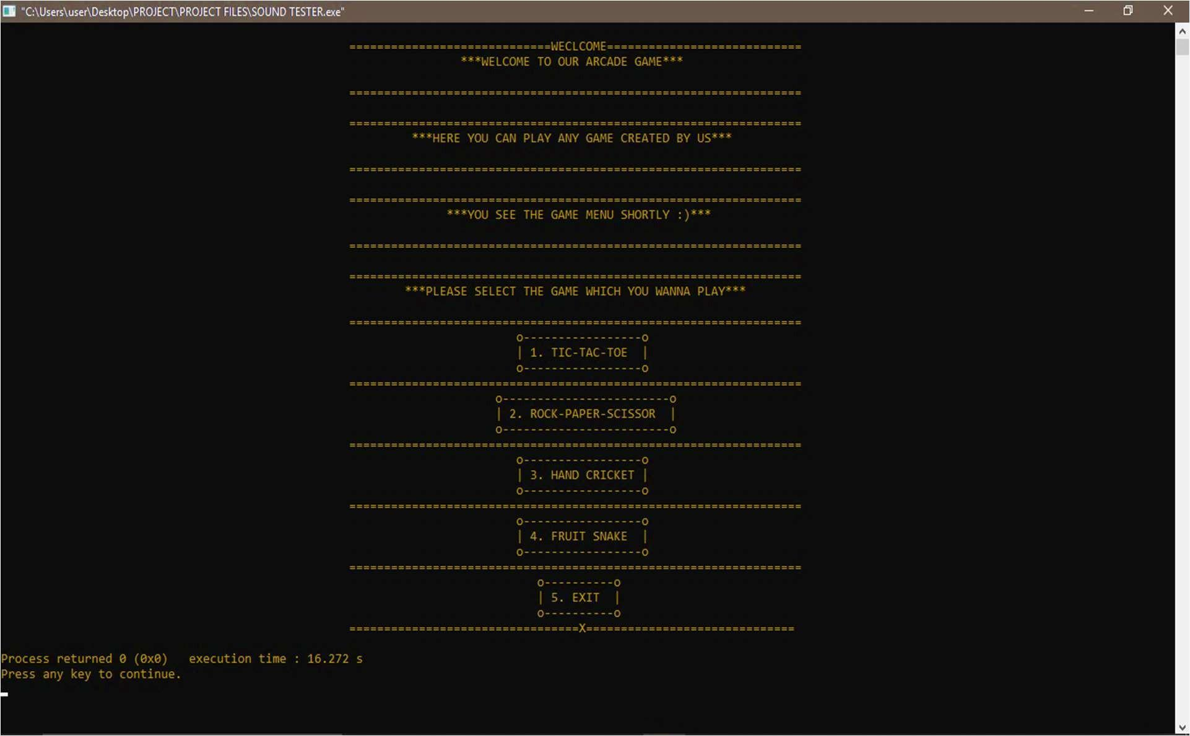

MAIN MENU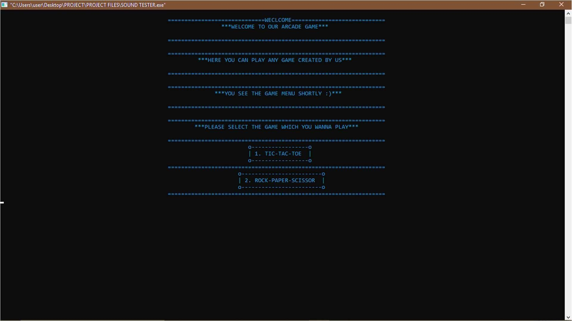

TIC TAC TOE

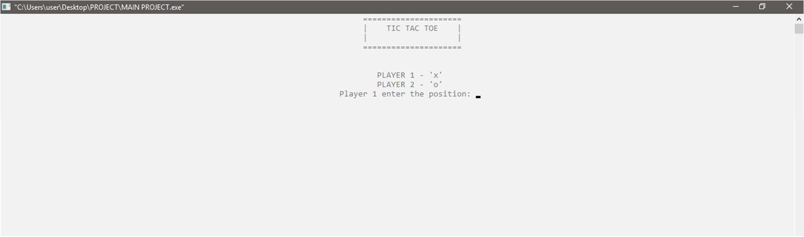

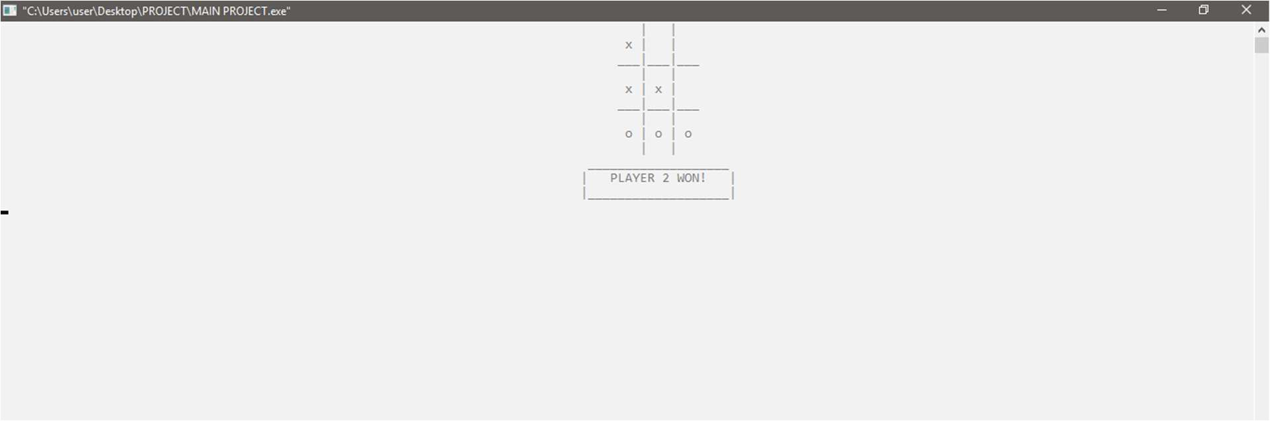

ROCK-PAPER-SCISSOR

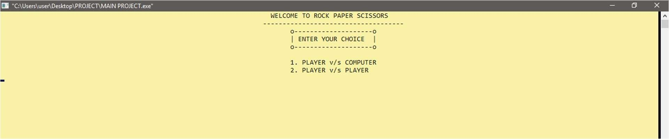

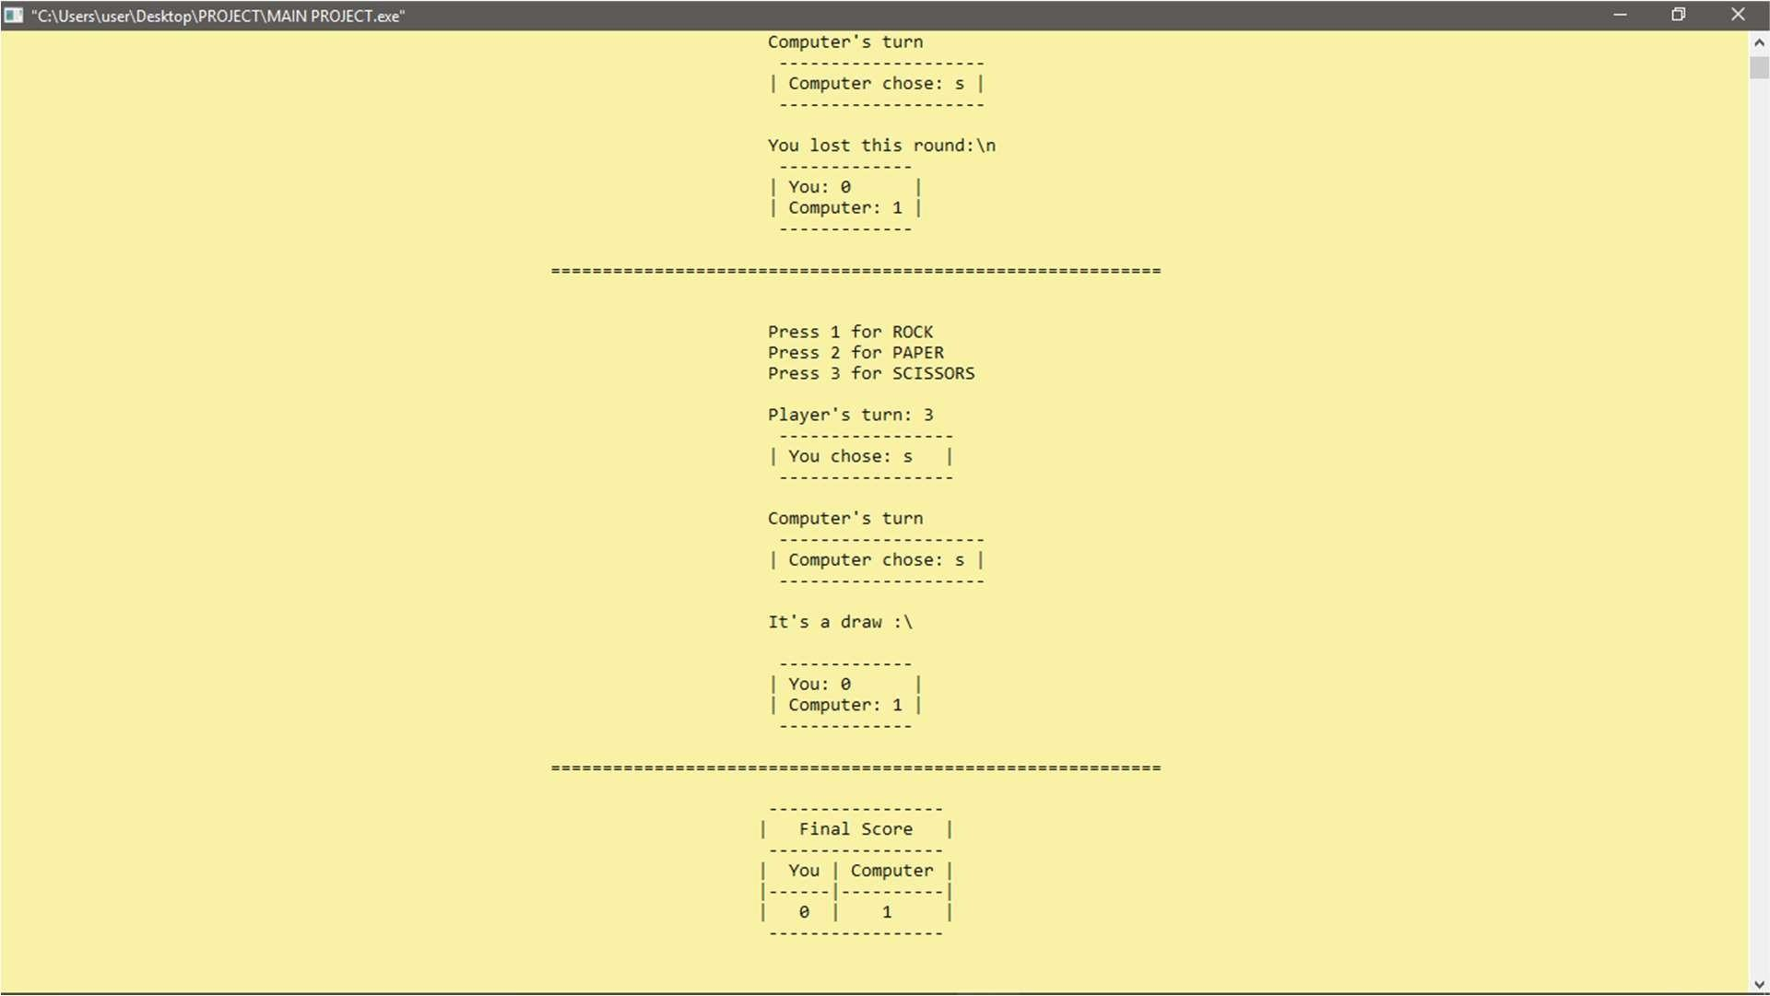

HAND CRICKET

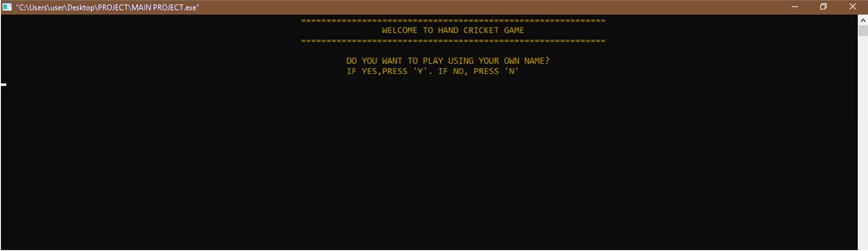

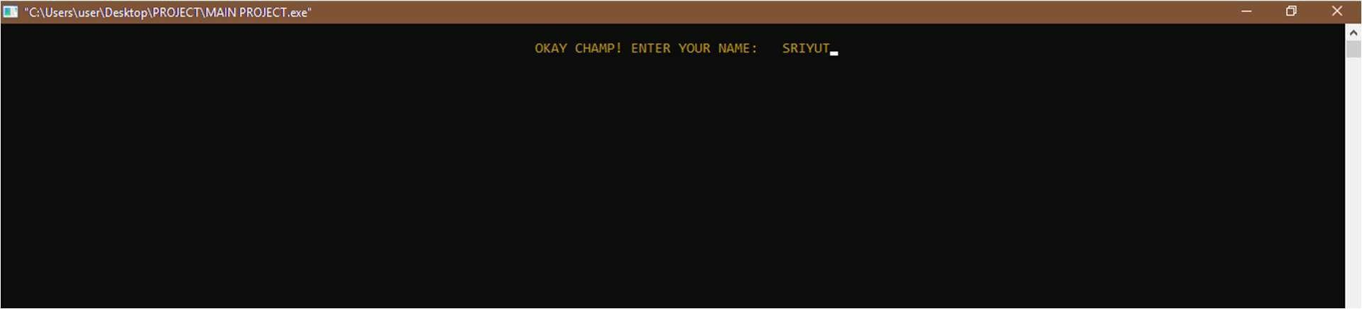

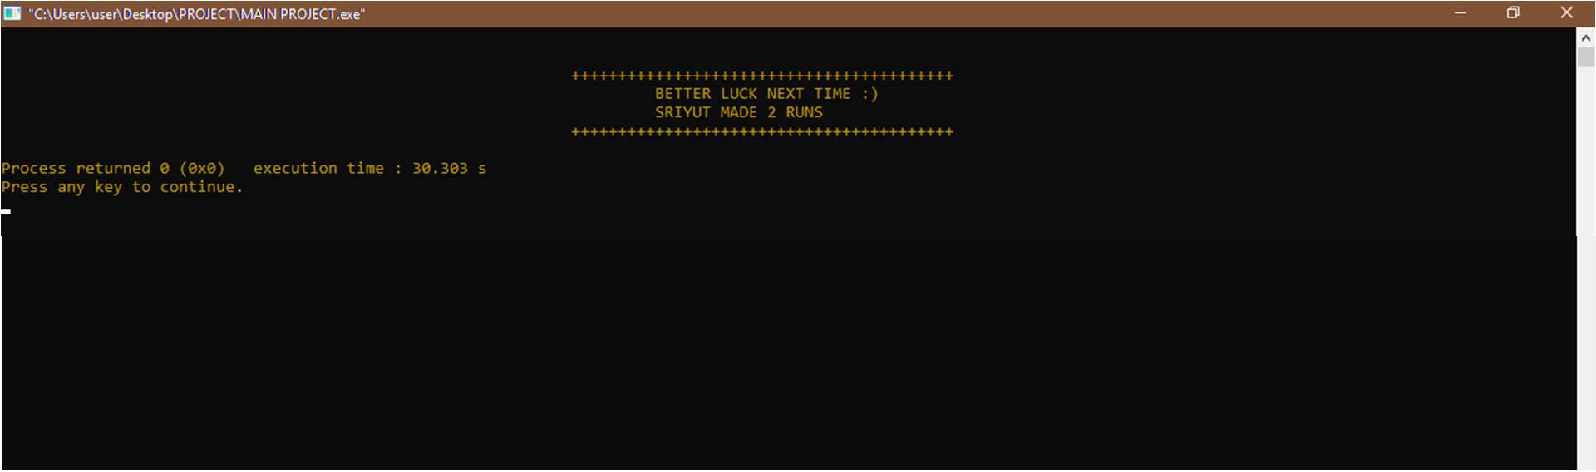

FRUIT SNAKE

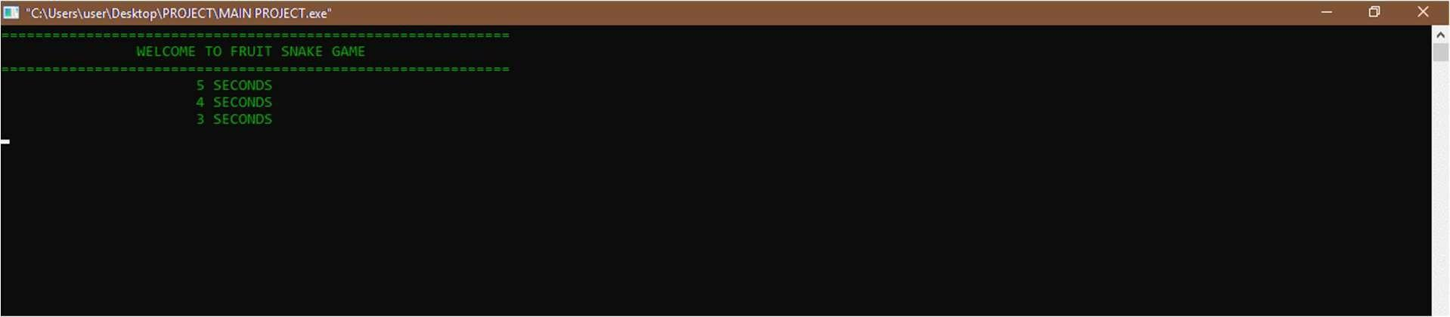

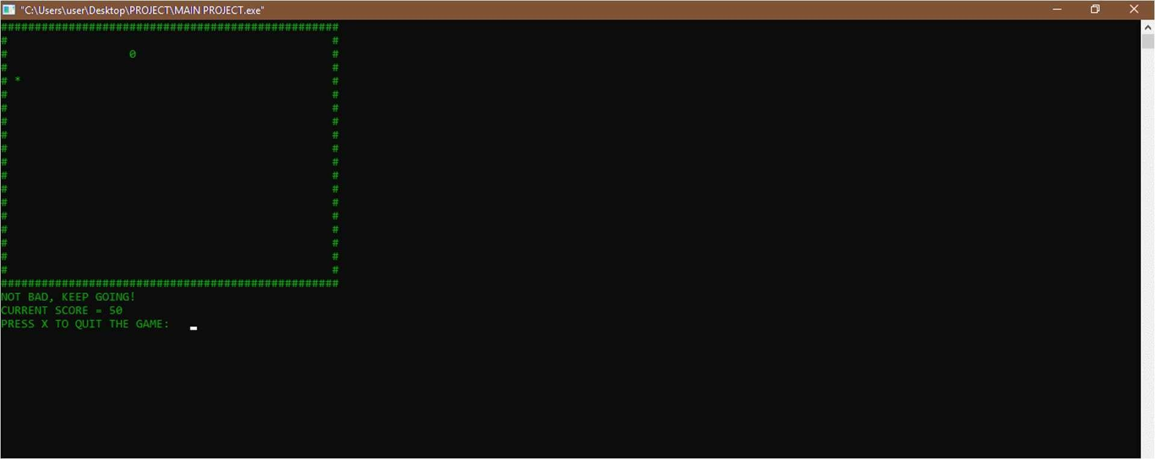

DRUNK MAN RACE

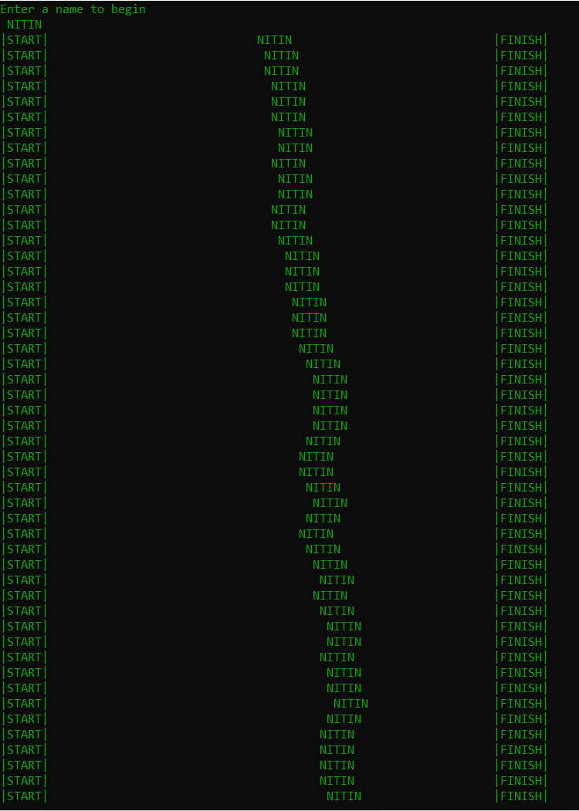

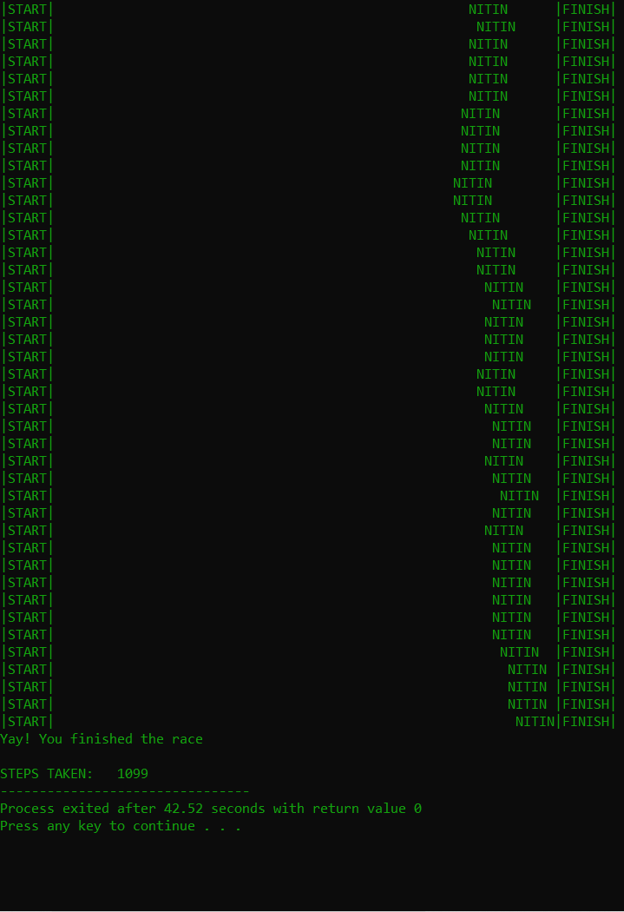

CASINO NUMBER GUESSING

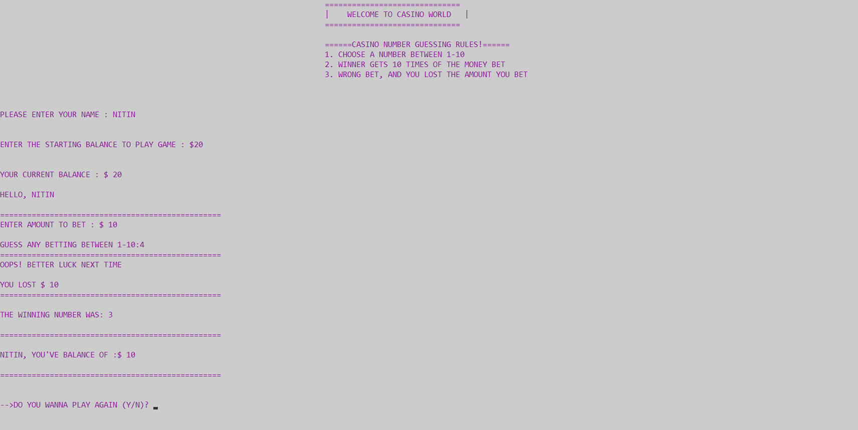

EXIT

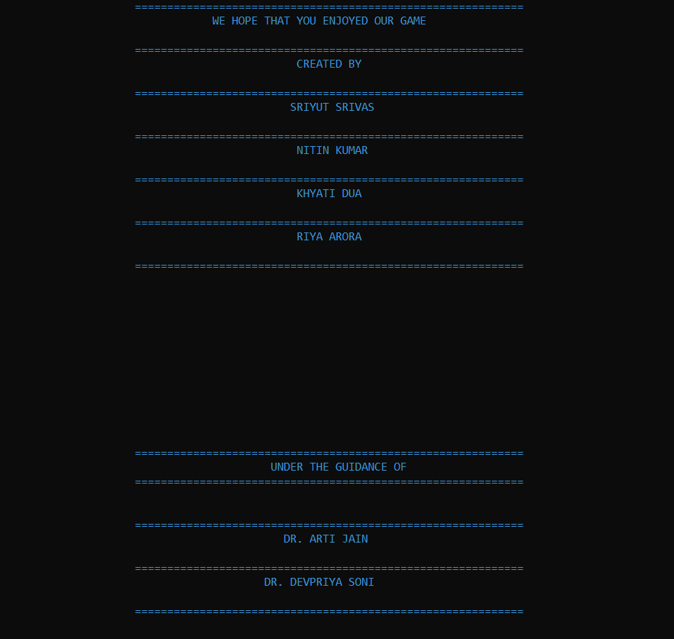

POST CREDITS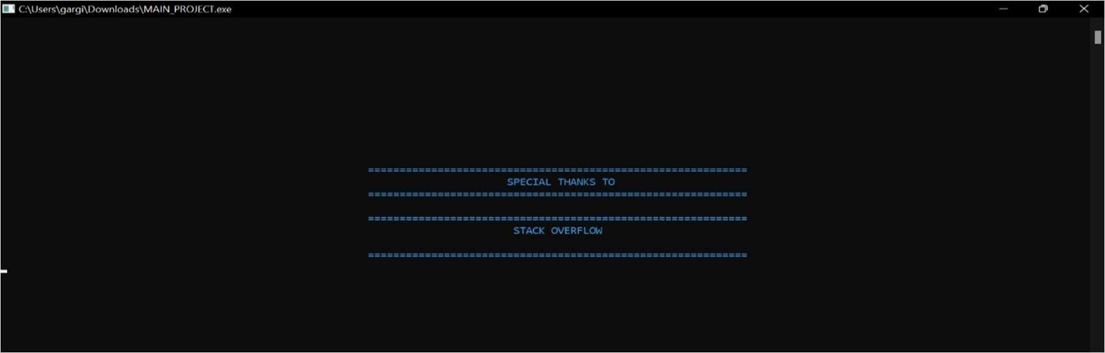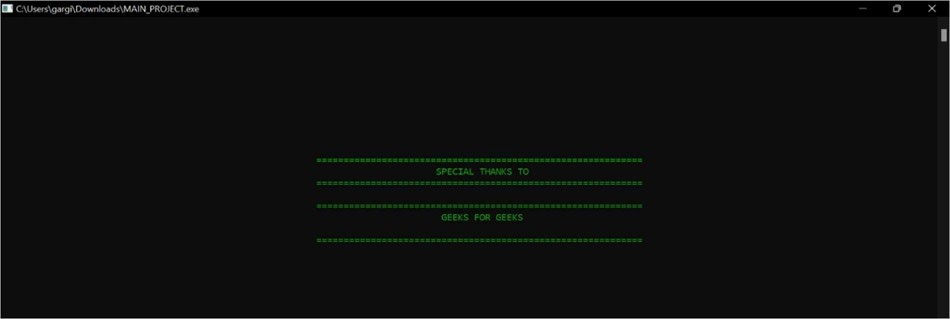

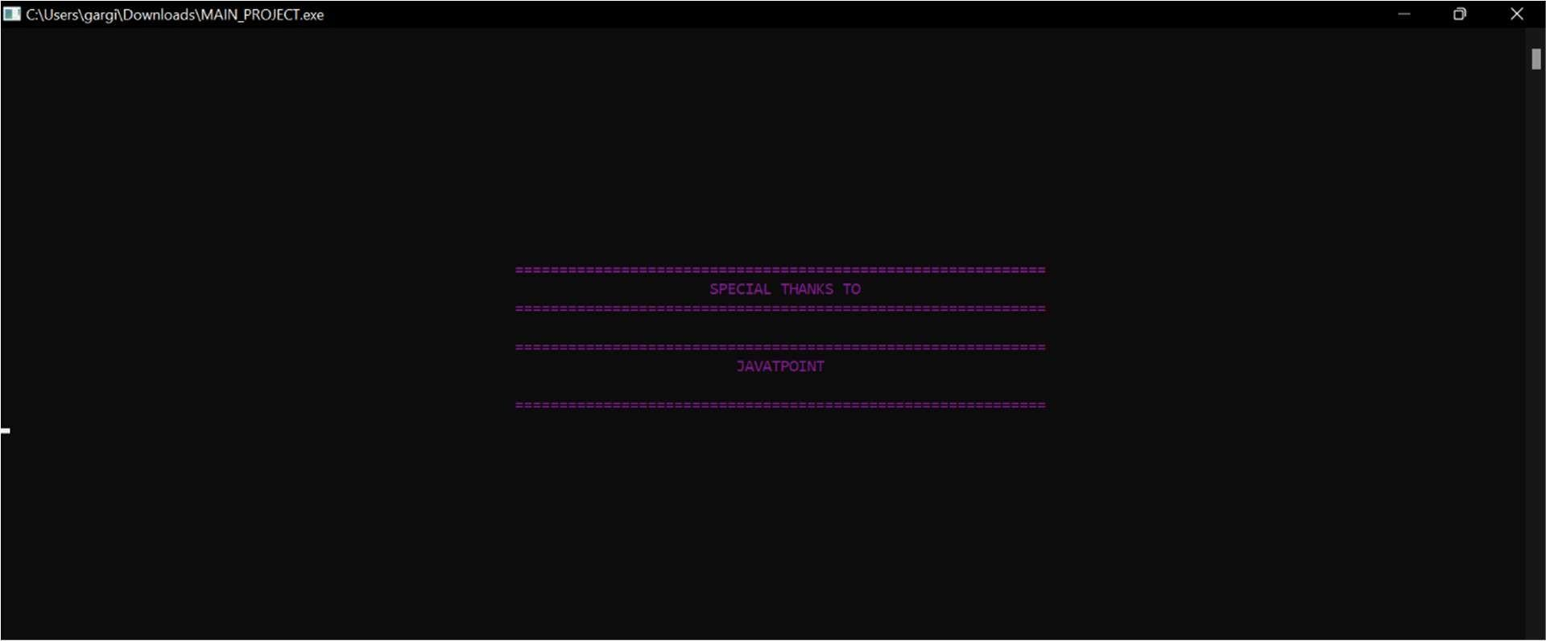

THANK YOU PAGE:-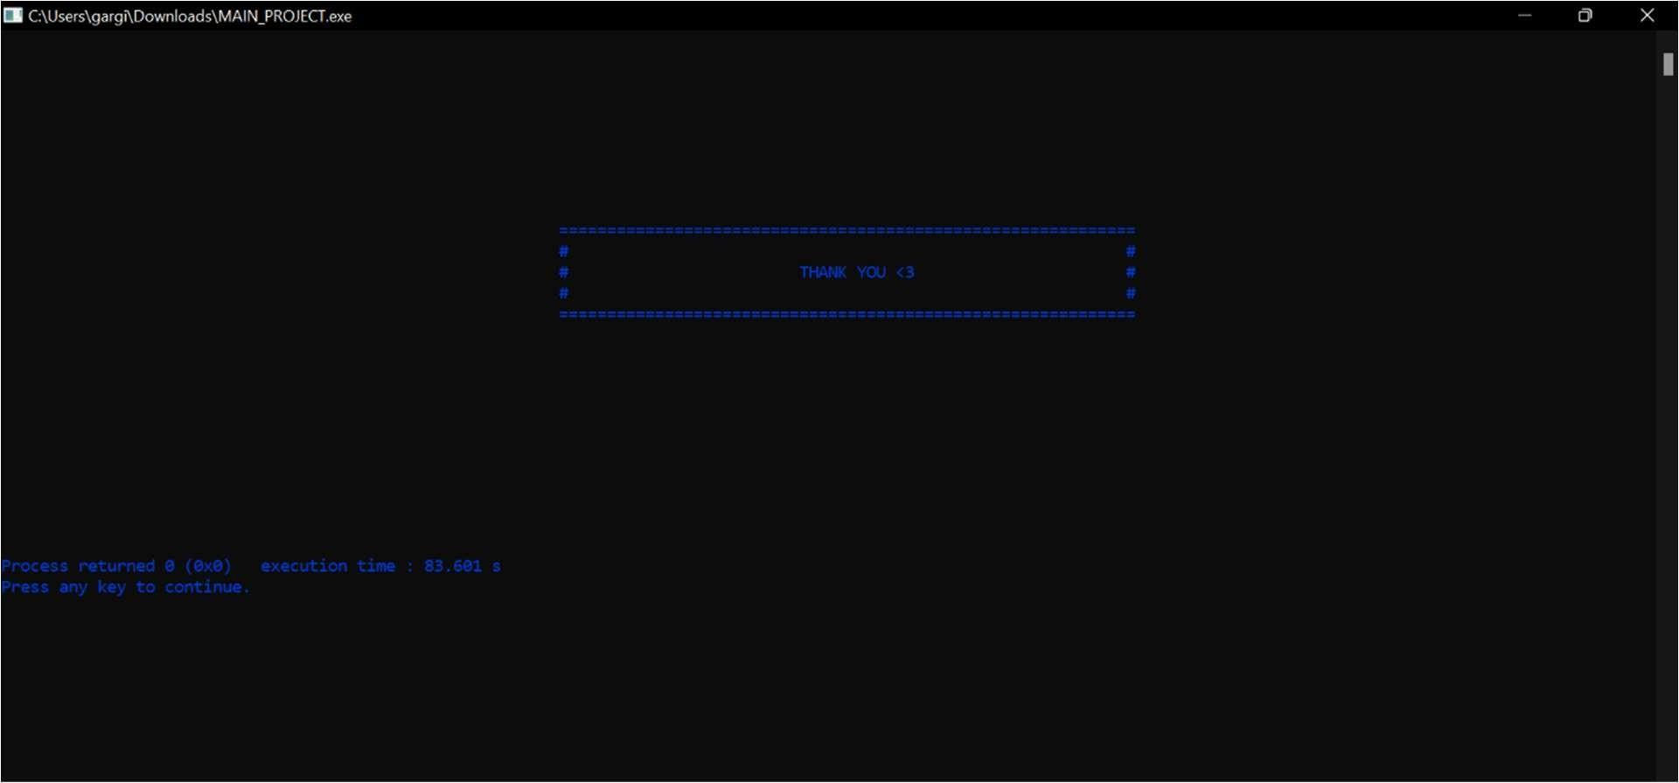

**CONCLUSION**

The purpose of this project is to implement and enrich our knowledge of programming in C++ language. Developing a gaming arcade helped us boost our cognition and understand logic building thoroughly. Apart from certain basic features provided in the language we learned to use various libraries, functions like rand (), srand (), how to delay execution of program, customize the color of our terminal and add sound files to make the project more interesting. We also learned the art of presenting our project more professionally. Through the experience of working as a group we inculcated various qualities of teamwork, leadership skills, time management which shall definitely help us in future.

We are extremely thankful to Mrs. Arti ma’am and Mrs. Devpriya ma’am for guiding us through this project.